SHIPSTON-ON-STOUR TOWN COUNCIL
 | New Clark House,  West Street,  Shipston-on-Stour  Warwickshire  CV36 4HD  Telephone:  01608 662180  Web Site: www.shipstononline.org | Town Mayor:  Cllr V Murphy | Councillors:  Mr B Cooper  Mr I Cooper  Mr M Ferrier  Mrs A Henderson  Mrs F Ivens  Mr K Perry  Mr P Rathkey  Mrs S Saunders  Mr D Scobie  Mrs J Warner  Mrs M Westwood  Mr P White | Town Clerk:  Georgina Beaumont  E-mail: clerk@shipstononline.org  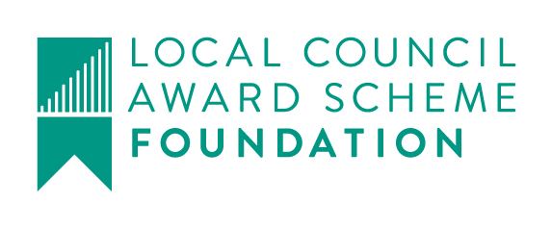  Over 100 years service  to the local community

Town and Country Planning Act 1990
Neighbourhood Planning (General) Planning Regulations 2012 (as amended)
Shipston-on-Stour Neighbourhood Development Plan
Regulation 14 - Pre-submission consultation and publicity
Notice is hereby given that Shipston-on-Stour Town Council, as the Qualifying Body, has prepared a neighbourhood development plan entitled the ‘Shipston-on-Stour Neighbourhood Development Plan’ for their Parish, with the help of the local community, and has formally published its Pre-submission Draft Plan for public consultation (see the link below).
The plan sets out a vision for the future of the Parish and planning policies which will be used to determine planning applications within the neighbourhood area. In accordance with Regulation 14 of Part 5 of The Neighbourhood Planning (General) Regulations 2012 (as amended), the Town Council must now publicise the Pre-submission Draft Plan for a minimum 6 week period inviting feedback from organisations and residents on the Pre-submission Draft Plan.
A copy of the Pre-submission Draft Plan, and supporting documentation, is available via the link below. Alternatively, hard copies of the documents are available for inspection at the Town Council offices, Shipston-on-Stour Post Office, and Shipston-on-Stour Community Library during normal working hours.

The consultation starts on 7th November 2016. Representations on the Pre-submission Draft Plan may be made to the Town Council by no later than 5pm on 31st December 2016. You are encouraged to submit your representations electronically. This can be done by using the on-line form (see link below). If you want to post your response, please send to Shipston-on-Stour Town Council, New Clark House, West Street, Shipston on Stour, CV36 4HD.

Link to the draft Neighbourhood Plan and comment sheet; http:www.shipstonnp.org/the-neighbourhood-plan.html

In addition, there are 4 ‘drop in’ sessions planned at the Town Council offices (New Clark House) for those residents who want to meet the Neighbourhood Plan team to discuss the plan face to face. These are;
Saturday 12th November-2pm to 4pm. Monday 14th November-4pm to 6pm.
Thursday 17th November-7pm to 9pm. Thursday 1st December-9.30am to 11.30am.

Consultation comment forms will also be available with the copies of the draft plan at the town centre locations, and at the ‘drop in’ sessions.
All representations received will be collated and will form possible amendments to the Pre-submission Draft Plan prior to submission to the Local Planning Authority.

